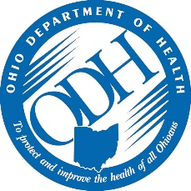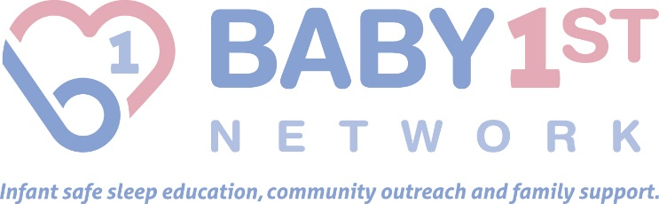

SIDS Risk Reduction & Infant Safe Sleep
Educational Workshop

Presented by Ohio Department of Health and
Baby 1st Network (formerly SID Network of Ohio)

We hope to see you at one of our two statewide training workshops that will be held in March (Akron) and April (Columbus). Learn from the experts about the impact of SIDS and SUID; risk factors and racial disparities;
recommendations for infant safe sleep and SIDS risk reduction; role of the hospital nurse educator; and role of the home visitor. You will also hear a personal story from a SUID parent and learn about the impact an infant death has on families. Please check your calendars and register today.

The Ohio Department of Health (OH-011, 4/1/2019) is an approved provider of continuing nursing education by the Ohio Nurses Association (OBN-001-91), an accredited approver by the American Nurses Credentialing Center’s Commission on Accreditation. The activity has been approved for 3.0 CNEs.

This activity has been approved for 3 CPE clock hours for Counselors, Social Workers and Marriage and Family Therapists.

The agenda is detailed below and there is a link provided on the Baby 1st website for the registration form. After you have completed the registration form, you may email it to carolyn.stroud@baby1stnetwork.org or fax it to (330) 929-0593. You will receive an email confirmation along with directions to the workshop so be sure to include your email address.

March 30, 2017
Summit County Public Health, Akron
12:00 – 3:15 pm

April 6, 2017
State Library of Ohio, Columbus
12:30 – 3:45 pm

Please feel free to call or email Carolyn Stroud at the
Baby 1st Network if you have any questions.
(800) 477-7437 or carolyn.stroud@baby1stnetwork.org

Ohio Department of Health and Baby 1st Network
SIDS Risk Reduction and Infant Safe Sleep Educational Workshop

Agenda

Registration – takes place during the 30 minutes prior to the workshop

Role of the Baby 1st Network

Impact of SIDS and SUID in Ohio and across the Nation
*How many babies die from SIDS and sleep related infant death in the state of Ohio?
*How is the state responding to lowering the risk of sleep related infant deaths?

Risk Factors and Racial Disparities
*What is SIDS/SUID?
*Risk factors for SIDS and sleep related infant deaths.
*Racial disparities that exist in overall infant mortality, SIDS and sleep related infant death.
*Why African Americans have higher SIDS rates and efforts to reduce the disparities.

Recommendations for Infant Safe Sleep and SIDS Risk Reduction
*Ways to reduce the risk
*Safe to Sleep Campaign
*American Academy of Pediatrics recommendations for safe sleep

Role of Hospital Nurse Educator
*Research regarding the impact of modeling safe sleep behavior by hospital staff.
*Recent Ohio law regarding hospital responsibilities for safe sleep education.
*Mandatory screening and referral for safe sleep space.

Role of Home Visitor
*Contact the family as soon as possible
*Home visit when appropriate
*Emphasis on bereavement support, not investigation
*Review the Report of Family Contact

Impact of Infant Deaths on Families
*SIDS parent personal story
*Grief responses and reactions
*Support from other family members and friends
*Community reaction

Questions, Answers and Evaluations

