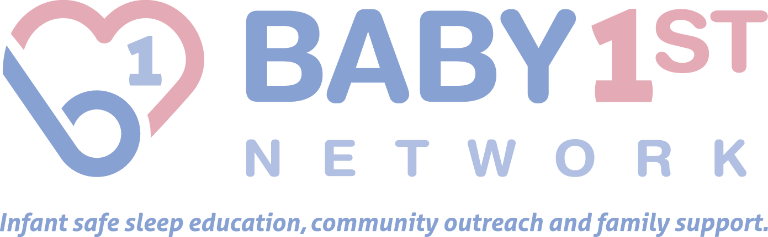
Infant Safe Sleep Mini-Grant Program

PURPOSE

SIDS Awareness Month is October. The Baby 1st Network created a mini-grant program to provide funding to neighborhood and community groups for outreach projects to reduce the risk of SIDS and other sleep-related causes of infant death in the state of Ohio. The purpose of the program is to increase community participation in disseminating the infant safe sleep message throughout the state.

The American Academy of Pediatrics guidelines for infant safe sleep practices are:

- Always place your baby on his or her back for every sleep time.
- Keep soft objects or loose bedding out of the crib. This includes pillows, blankets, and bumper pads.
- The safest place for your baby to sleep is in the room where you sleep, but not in your bed. Never place babies to sleep on adult beds, chairs, sofas, waterbeds, pillows, cushions or soft surfaces.
- Dress your baby in sleep clothing, such as a sleep sack, and do not use a blanket.
- Avoid letting the baby get too hot. Keep room temperatures in a range comfortable for a lightly clothed adult.
- Infants should receive all recommended vaccinations.
- Breastfeeding is recommended to help to reduce the risk of SIDS.
- Avoid smoke exposure during pregnancy and after birth. Place the crib in an area that is always smoke free.
- Supervised, awake tummy time is recommended daily to facilitate development.
- Consider using a pacifier at naptime and bedtime, once breastfeeding is well established.
- Talk to those who care for your baby, including childcare providers, family, and friends, about placing your baby to sleep on their back for every sleep.
- Obtain regular prenatal care to reduce the risk of SIDS even before birth.
- Avoid alcohol and illicit drug use during pregnancy and after birth.
Funds are to be used for educational initiatives in the state of Ohio that work to promote infant safe sleep practices and increase public awareness regarding the impact of sleep-related infant deaths, and ways to reduce these incidences.

Examples of community programs to be considered for a mini-grant include, but are not limited to:

- Infant safe sleep demonstrations
- Infant safe sleep trainings and workshops
- Infant safe sleep community awareness events
- Infant safe sleep community “baby showers” (awareness event with educational resources and prize giveaways)
- SIDS Sunday awareness event organized by churches

BACKGROUND

Sudden Unexpected Infant Deaths (SUID) are defined as deaths that occur suddenly and unexpectedly in infants less than 1 year of age, and whose cause of death are not immediately obvious prior to investigation. After a full investigation, these causes of death may be diagnosed as suffocation, asphyxia, entrapment, infection, ingestions, metabolic diseases, cardiac arrhythmias, trauma (accidental or non-accidental), or SIDS. Sleep Related Infant Deaths are those deaths that happen suddenly and unexpectedly in a sleep environment.

Sudden Infant Death Syndrome (SIDS) is marked by the sudden death of an infant under 1 year of age, which remains unexplained after a thorough case investigation - including performance of an autopsy, examination of the death scene, and a review of the clinical history.

In Ohio from 2011-2015, sleep related infant deaths accounted for 16% (770) of all infant deaths reviewed and 60% (461) for infants between one month and three months of age. Eighty-nine percent of reviewed sleep-related deaths were for infants between 29 days and 1 year of age. Fifty-three percent (406) of these deaths occurred to infants who were sharing a sleep surface with another person (bed sharing). Among reviews indicating bed sharing, infants most often shared a sleep surface with an adult (69%), an adult and another child (18%), or another child (6%). Only 23% (177) occurred in cribs or bassinets! In addition, forty-eight percent of sleep related infant deaths were diagnosed as an undetermined cause and 11% were diagnosed as SIDS. Infants were put to sleep on their back in 40% of reviewed deaths.*

According to 2015 infant mortality data released by the Ohio Department of Health, 1,005 infants died before their first birthday, an increase from 955 deaths in 2014. Racial disparities persist with Ohio’s white infant mortality rate at 5.5 and the black infant mortality rate at 15.1. Black infants are dying at nearly 3 times the rate of white infants.

APPLICATION PROCEDURE

•A complete application form and a detailed project budget must be submitted. Please do not include other printed materials, CD’s, videos or audiotapes. Any such additional materials will not be considered. All applications must be completed and delivered by mail or email in accordance with the instructions contained herein. Requests will be reviewed by the Baby 1st Network advisory committee.
•Amount requested may not exceed $500. Applications that describe cash and in-kind matching funds will be viewed more favorably.
•Requests must be postmarked by the dates below for consideration, and any requests received after the deadline may be rejected or held for future cycles, as determined by the Baby 1st Network advisory committee. Projects cannot begin before the specified project start date of October 1, 2017 and must be completed by November 30, 2017. There are no exceptions.
•All approved mini-grant applications will be required to have a representative participate in a mandatory orientation webinar/meeting scheduled approximately one week after award notification. Additional information regarding this meeting will be included in your notice of award letter, if approved for funding.
•All approved applicants are required to send a representative who must be prepared to present on the organization’s mini-grant activities and project highlights at a mandatory closeout webinar/meeting that will be held approximately one week after the project period ends.

*Ohio Child Fatality Review Sixteenth Annual Report

PROJECT TIMELINE:
Infant Safe Sleep Mini-Grant projects will occur between October 1-November 30, 2017.

Grant Technical Assistance Conference Call: August 31, 2017, 7 pm
Application deadline: September 13, 2017
Award notification date: September 20, 2017
Orientation Webinar: September 27, 2017, 1 pm
Closeout Webinar/Meeting and Final Reports Due: December 13, 2017, 1 pm
The Grant Technical Assistance Conference Call is new to our mini-grant proposal process, but is not required. Open to any prospective applicant, this is an opportunity to ask your questions about the grant’s requirements and/or guidelines. To participate in the one-hour call, at 7 pm, Thursday,
August 31: dial 1 408 638 0968 (US Toll) or 1 646 558 8656 (US Toll). Meeting ID: 670 496 178
For questions pertaining to this mini-grant program or application, please contact Dr. Stacy Scott, at stacy.scott@baby1stnetwork.org or (419) 490-5993.

TERMS AND/OR GUIDELINES

• The programs created with the assistance of an Infant Safe Sleep Mini-Grant should be promoted and offered to the general public within the state of Ohio, with special emphasis directed to underserved populations and/or geographic areas within the state of Ohio including African American communities.
- Only tax-exempt organizations are eligible to apply. Eligible groups may include, but are not limited to civic and neighborhood organizations, social service groups, cultural organizations, and faith based organizations. Commercial, for-profit businesses and individuals are ineligible. All projects should be open and promoted to the general public. The Baby 1st Network cannot fund projects when the purpose or content of the project is to advance a religious ideology.
• Infant Safe Sleep Mini-Grants are not intended to be a recurring funding source for organizations, as one of the goals of the program is to distribute funds across the many geographic regions and cultural communities throughout the state. In general, organizations can only receive one grant per calendar year.
• Infant Safe Sleep Mini-Grants will not be awarded for the following:
- Dues
- Operating deficits and/or support
- Publication of books
- Capital improvements/building projects
- Chairs or professorships
- Endowments, annual fund drives, direct mail solicitation, fundraising events
- Purchase of food and advertising space.
- Prior approval from the Baby 1st Network must be received if funds will be used to purchase products such as T-shirts, cribs, crib sheets, and sleep sacks.
- Projects intended to influence legislation or support candidates for political office
- Use by another foundation or organization to distribute the funds to recipients of its own selection.
The Baby 1st Network reserves the right, under certain circumstances, to make exceptions to the above.
•Organizations receiving funds through the Infant Safe Sleep Mini-Grant Program must acknowledge support through placement of the Baby 1st Network Infant Safe Sleep Mini-Grant Program logo on all project-related printed materials, including websites. Verbal acknowledgment must be given where printed acknowledgment is not possible. Prior approval of any materials upon which either logo will be placed should first be obtained from the Baby 1st Network.
• A minimum of 20 participants must be reached with the project. Success of an event will be taken into consideration in connection with any future mini-grant applications. All approved applicants will be required to document activities, lesson learned – both positive and negative, and complete all project forms. Sign-in sheets are required at each project event. Please take photos if possible.
- The Baby 1st Network can assist groups with free brochures, posters and other information to help promote the infant safe sleep message.
•Organizations receiving funds through the program must submit a brief final report on the funded project, including actual date(s) of occurrence, project outcomes, summary of expenditures paid for with awarded funds, photo documentation of project, pre and post survey results and evaluation results including audience/beneficiary feedback, by the mandatory closeout meeting.
• Incomplete applications will not be reviewed. Each proposal will be considered on its own merit. Additional information may be requested if it will assist in the review process. The Baby 1st Network reserves the right to reject an Infant Safe Sleep Mini-Grant application for any reason, including a missed deadline or incomplete information.

This program made possible through funding from these annual events: Nolan P. Fisher Golf Outing, Corbin Hastings Memorial Day Ride/Run, Laura Elizabeth Pease Memorial Golf Outing, Brianna Dawn Tully Memorial Golf Outing, SIDS Golf Benefit, Justin Prestage Golf Outing and Auction and Grant’s SIDS 5k Run/Walk.

