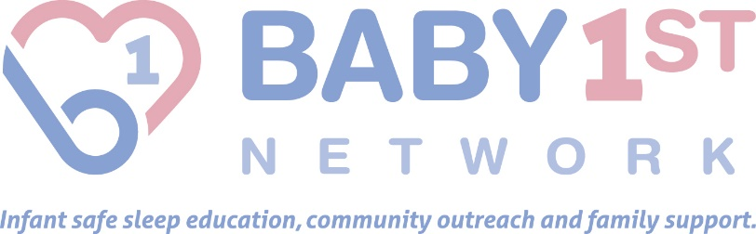
INFANT SAFE SLEEP MINI-GRANT PROGRAM
APPLICATION
The INFANT SAFE SLEEP MINI-GRANT PROGRAM is administered by the Baby 1st Network. See Program Guidelines for details. All applications must be completed and delivered by mail or email by May 16, 2017. Applications will not be accepted by fax.

Mail or email your completed application to: For questions regarding this application:
Infant Safe Sleep Mini-Grant Program Please contact:
C/O Baby 1st Network Dr. Stacy Scott, Program Manager
421 Graham Rd, Suite H (419) 490-5993
Cuyahoga Falls, OH 44221 stacy.scott@baby1stnetwork.org
800-477-7437
elizabeth.wilson@baby1stnetwork.org

DATE: _________________________________
I. APPLYING ORGANIZATION
1. Organization Name: _____________________________________________________________ Year started: ____
2. Address: _______________________________________________________________________________________
3. City, state, zip: _________________________________________________________________________________
4. Website: ______________________________________________________________________________________
5. Telephone: (___) ________________________________________________________________________________
6. Contact person/Title: ____________________________________________________________________________
7. Contact email: __________________________________________________________________________________
8. Alternate contact person/Title: ____________________________________________________________________
9. Tax exempt status: Is your organization a 501C3? ___ YES ___NO. If not, then 501 c (____) insert number.
Tax ID#: ___________________________________________
10. Check one category that best describes your organization: ☐ Civic Assoc. ☐ Human Services ☐ Arts Organization ☐ Faith Based ☐ Other: _____________________________________________________(please explain)

11. Please provide a mission statement or brief history of your organization’s role in the community. (Attach a maximum one additional page to complete if necessary. Please do not include other printed material, CDs, videos, etc.)

II. PROJECT SUMMARY (Attach a maximum one additional page to complete Section II if necessary.)
Must include how this activity will impact your community in terms of reducing the risk of SIDS and promoting infant safe sleep. Explain how the project will be carried out; how the funds will be used and the expected results of the project.
12. A) Project Title: _________________________________________________________________________
B) Project Description:

C) Project Start Date: _________________________ Project End Date: ____________________
D) Project Location (address including zip code):

E) County where the activity/project will occur: _______________________________
F) Do you have any project partners? If so, please list partners and their contribution (An organization may be considered a project partner if it is a co-sponsor of the project, or contributes cash, facilities, goods or services to the project):

G) Describe target audience/beneficiaries for your project:

H) Projected number of beneficiaries (Participants and/or Audience): _______________
I) How will an Infant Safe Sleep Mini-Grant program improve or enhance your project?

J) Attach a project budget. Must include a detailed listing of income (both cash and in-kind) and a detailed listing of expenses.
13. Request: (maximum $500) ___________________________
III. SIGNATURE
Authorized Official’s Signature _______________________________________ Date ___________
Print Name ___________________________________________________________________
Title ___________________________________________________________________

